***B.Tech 2020-24 CSE- Project***

***Proposal***

1. ***Group No.: B4***

***Project Title:***

*Brain Tumor Segmentation with Graphing*

***Team members:***

|  |  |
| --- | --- |
| *Roll No.* | *Name* |
| *AM.EN.U4CSE20157* | *NIHAAS REDDY RAVULA* |
| *AM.EN.U4CSE20115* | *DHEERAJ REDDY BALASANI* |
| *AM.EN.U4CSE20167* | *KARTHEEK VISHAL REDDY T* |

1. ***Abstract***

*The Brain Tumor presents a highly critical situation concerning the brain, characterized by the*

*uncontrolled growth of an abnormal cell cluster. Early brain tumor detection is essential for accurate*

*diagnosis and effective treatment planning. In this paper, a novel Convolutional Neural Network*

*(CNN) based Graph Neural Network (GNN) model is proposed using the publicly available Brain*

*Tumor dataset from Kaggle to predict whether a person has brain tumor or not.*

*One of the objectives of this project is to provide a solution to the existing problem where the non-consideration of non-Euclidean distances in image data and the inability of conventional models to learn on pixel similarity based upon the pixel proximity.*

*We are aiming at improving brain tumor detection and classification using a novel technique*

*which combines GNN and a 26 layered CNN that takes in a Graph input pre-convolved using Graph*

*Convolution operation.*

1. ***Background Study***

|  |  |  |  |  |
| --- | --- | --- | --- | --- |
| *Title &year* | *Problem* | *Contributions* | *Limitations* | *Open problems/Future work* |
| *Brain Tumor Detection and Classification Using Intelligence Techniques: An Overview.*  *IEEE Access, vol. 11, pp. 12870-12886, 2023* | *Early detection of brain tumors is crucial for improving treatment outcomes. However, traditional methods of brain tumor detection, such as manual visual inspection of MRI scans, are time-consuming, subjective, and prone to error.* | *This paper provides a comprehensive overview of intelligent techniques for brain tumor detection and classification. The authors discuss the different types of intelligent techniques that have been used for this task, as well as their advantages and limitations.* | *The authors acknowledge that there is still a need for more research on intelligent techniques for brain tumor detection and classification.* | *They suggest that future research should focus on developing more robust and accurate methods, as well as methods that can be applied to real-time data.* |
| *Brain Tumor Segmentation from Magnetic Resonance Image Data Using Ensemble Learning Methods Brain Tumor Segmentation from Magnetic Resonance Image Data Using Ensemble Learning Methods.*  *2021 IEEE International Conference on Image Processing (ICIP), pp. 1255-1259, 2021* | *Brain tumor segmentation is a challenging task due to the complex and heterogeneous nature of brain tumors. Traditional methods of brain tumor segmentation, such as thresholding and edge detection, are often not accurate enough.* | *This paper proposes a new ensemble learning method for brain tumor segmentation from MRI data. The proposed method combines multiple deep learning models to achieve higher accuracy.* | *The authors acknowledge that the proposed method is computationally expensive.* | *They suggest that future research should focus on developing more efficient ensemble learning methods.* |
| *Design and Implementing Brain Tumor Detection Using Machine Learning Approach.*  *2020 5th International Conference on Computer and Communication Engineering (ICCEE), pp. 1-5, 2020* | *Brain tumor detection is a critical task for early diagnosis and treatment. However, traditional methods of brain tumor detection, such as manual visual inspection of MRI scans, are time-consuming, subjective, and prone to error.* | *This paper proposes a machine learning approach for brain tumor detection using MRI scans. The proposed method uses a convolutional neural network (CNN) to classify MRI images as either normal or brain tumor.* | *The authors acknowledge that the proposed method is limited by the size of the training dataset.* | *They suggest that future research should focus on collecting larger datasets to improve the accuracy of the CNN model.* |
| *A Literature Review on Brain Tumor Detection and Segmentation IEEE Access, vol. 7, pp. 12978-12990, 2019* | *Brain tumor detection and segmentation are important tasks for medical diagnosis and treatment planning. However, these tasks are challenging due to the complex and heterogeneous nature of brain tumors.* | *This paper provides a literature review of brain tumor detection and segmentation methods. The authors discuss the different types of methods that have been used for these tasks, as well as their advantages and limitations..* | *The authors acknowledge that there is still a need for more research on brain tumor detection and segmentation methods.* | *They suggest that future research should focus on developing more accurate and robust methods, as well as methods that can be applied to real-time data.* |
| *Brain Tumor detection Using Machine Learning and Deep Learning Approaches.*  *2018 IEEE International Conference on Systems, Man, and Cybernetics (SMC), pp. 2427-2432, 2018* | *Brain tumors are one of the leading causes of cancer-related deaths worldwide. Early detection and treatment of brain tumors is crucial for improving patient outcomes. However, traditional methods of brain tumor detection, such as manual visual inspection of MRI scans, are time-consuming, subjective, and prone to error.* | *This paper discusses the various machine learning and deep learning approaches that have been used for brain tumor detection. The authors discuss the advantages and limitations of each approach, as well as future directions for research.* | *The authors acknowledge that there is still a need for more research on machine learning and deep learning approaches for brain tumor detection.* | *They suggest that future research should focus on developing more accurate and robust methods, as well as methods that can be applied to real-time data.* |

1. ***Challenges***

* *The existing problem where the non-consideration of non-Euclidean distances in image data and the inability of conventional models to learn on pixel similarity based upon the pixel proximity.*
* *Understanding the decisions made by GCNNs is crucial, especially in medical applications. Interpreting the predictions of GCNNs and explaining why a certain region is identified as a tumor or not can be challenging.*
* *Ensuring that the trained GCNN can generalize well to unseen data from different scanners, patient demographics, or imaging protocols is essential for real-world deployment.*
* *The conventional image representation of nxn matrix has certain drawbacks and the model lack the capacity to retain and utilize the pixel related information.*

1. ***Deliverables of Phase I***

|  |
| --- |
| * *To tackle the challenges mentioned with an approach that combines gnn and cnn that classifies the brain tumor into different classes.* * *The conventional image representation of nxn matrix has certain drawbacks and the model lack the capacity to retain and utilize the pixel related information, to tackle this we are generating a standard pre computed weighted adjacency matrix kernel.* * *Give a working model with image data conversion to graph giving accurate classification.* |

1. ***Assumptions/Declarations:***

|  |
| --- |
| *Assumptions:*   * *GCNNs assume that the spatial relationships and connectivity within the brain, represented as a graph, hold significant information for tumor detection. The assumption is that preserving this topology through graph convolutions helps in identifying tumor regions.* * *There's an assumption that the trained model will generalize well to unseen data. This assumes that the patterns learned from the training data are applicable to new, unseen brain scans, especially those from different populations or acquired using different imaging protocols.* * *The effectiveness of GCNNs relies on having a representative dataset that sufficiently covers the diversity of brain tumors in terms of size, shape, location, and appearance. The assumption is that the model can learn generalizable patterns from this dataset.*   ***Dataset Details:***   * *The dataset used in the brain tumor PDF contains MRI (magnetic resonance imaging) images of the brain. Specifically, the dataset includes 3264 MRI images of different patients, primarily classified into 4 categories: No Tumor, Pituitary Tumor, Glioma Tumor, Meningioma Tumor, and Sarcoma Tumor.* * *The dataset used in the brain tumor PDF is a public dataset available in the Brain Tumor Classification Dataset repository on Kaggle. The dataset is identified by the DOI number 10.34740/KAGGLE/DSV/1183165* |

1. ***Tools to be used***

|  |  |
| --- | --- |
| ***Software/Hardware Tools*** | ***Specifications*** |
| *Python* | *Python has extensive libraries and frameworks for data processing, computer vision, and deep learning.* |
| *Dependencies and libraries* | *Numpy>=1.17*  *Scipy>=1.4*  *Scikit-image*  *Networkx*  *Nibabel*  *Pytorch>=1.7*  *DGL>=0.4* |
| *Flutter* | *Flutter used to develop application in both mobile and web* |
| *Laptop, webcam, mobile phone* | *To develop test and deployment* |

***High Level Design***

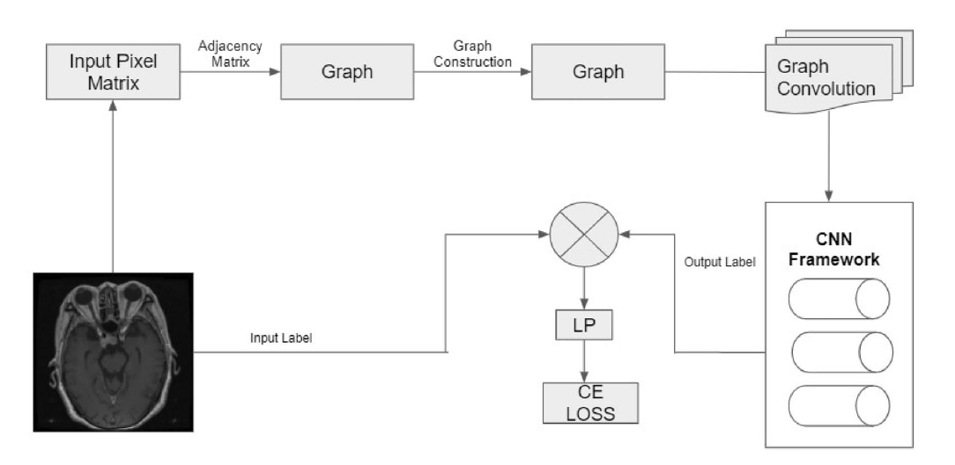

**

*NIHAAS REDDY R*

**

*DHEERAJ REDDY B*

**

*KARTHEEK VISHAL REDDY T*

**

***Asha Ashok***

*Asst. Professor, School of Computing, Amritapuri*